**Gradient Calculation**

In the last few videos, we learned that in order to minimize the error function, we need to take some derivatives. So let's get our hands dirty and actually compute the derivative of the error function. The first thing to notice is that the sigmoid function has a really nice derivative. Namely,

σ′(x)=σ(x)(1−σ(x))

The reason for this is the following, we can calculate it using the quotient formula:

[[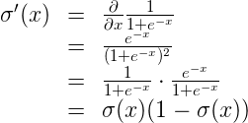](https://classroom.udacity.com/courses/ud188/lessons/b4ca7aaa-b346-43b1-ae7d-20d27b2eab65/concepts/0d92455b-2fa0-4eb8-ae5d-07c7834b8a56)](https://classroom.udacity.com/courses/ud188/lessons/b4ca7aaa-b346-43b1-ae7d-20d27b2eab65/concepts/0d92455b-2fa0-4eb8-ae5d-07c7834b8a56)

And now, let's recall that if we have mmm points labelled



the error formula is:

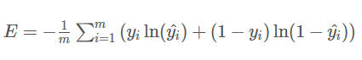

where the prediction is given by



Our goal is to calculate the gradient of E, at a point x=(x1,…,xn),

given by the partial derivatives

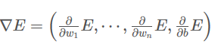

To simplify our calculations, we'll actually think of the error that each point produces, and calculate the derivative of this error. The total error, then, is the average of the errors at all the points. The error produced by each point is, simply,



In order to calculate the derivative of this error with respect to the weights, we'll first calculate . Recall that , so:

[[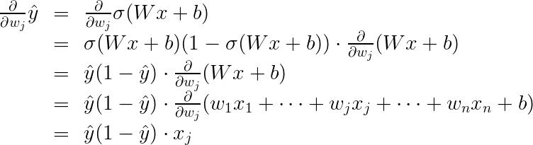](https://classroom.udacity.com/courses/ud188/lessons/b4ca7aaa-b346-43b1-ae7d-20d27b2eab65/concepts/0d92455b-2fa0-4eb8-ae5d-07c7834b8a56)](https://classroom.udacity.com/courses/ud188/lessons/b4ca7aaa-b346-43b1-ae7d-20d27b2eab65/concepts/0d92455b-2fa0-4eb8-ae5d-07c7834b8a56)

The last equality is because the only term in the sum which is not a constant with respect to wjw_jwj​ is precisely wjxj ​, which clearly has derivative xj.

Now, we can go ahead and calculate the derivative of the error E at a point x, with respect to the weight wj:

[[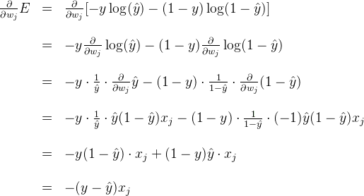](https://classroom.udacity.com/courses/ud188/lessons/b4ca7aaa-b346-43b1-ae7d-20d27b2eab65/concepts/0d92455b-2fa0-4eb8-ae5d-07c7834b8a56)](https://classroom.udacity.com/courses/ud188/lessons/b4ca7aaa-b346-43b1-ae7d-20d27b2eab65/concepts/0d92455b-2fa0-4eb8-ae5d-07c7834b8a56)

A similar calculation will show us that

[[https://d17h27t6h515a5.cloudfront.net/topher/2017/September/59b75d1d_codecogseqn-58/codecogseqn-58.gif](https://classroom.udacity.com/courses/ud188/lessons/b4ca7aaa-b346-43b1-ae7d-20d27b2eab65/concepts/0d92455b-2fa0-4eb8-ae5d-07c7834b8a56)](https://classroom.udacity.com/courses/ud188/lessons/b4ca7aaa-b346-43b1-ae7d-20d27b2eab65/concepts/0d92455b-2fa0-4eb8-ae5d-07c7834b8a56)

This actually tells us something very important. For a point with coordinates (x1,..xn), label y, and prediction y_hat, the gradient of the error function at that point is .In summary, the gradient is

.

If you think about it, this is fascinating. The gradient is actually a scalar times the coordinates of the point! And what is the scalar? Nothing less than a multiple of the difference between the label and the prediction. What significance does this have?

**Quiz Question**

What does the scalar we obtained above signify? (Check all that are true.)

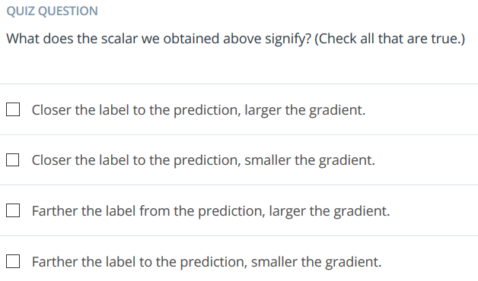

So, a small gradient means we'll change our coordinates by a little bit, and a large gradient means we'll change our coordinates by a lot.

If this sounds anything like the perceptron algorithm, this is no coincidence! We'll see it in a bit.

